Dash Boards Creation

1.Login to azure portal and click right side and select Dash Boards.

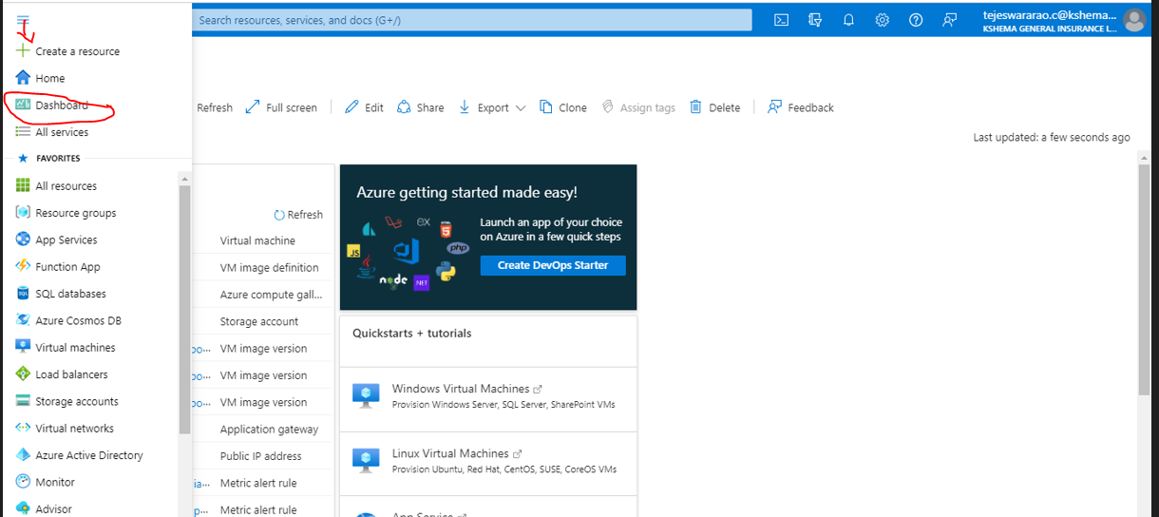

**2.Click on Create**

**3. Create a Custom Dash Boards**

**4. Create a Custom dash board, now click Left side Till Gallery here we need to select whatever we want for custom Dash boards. For example here I selected metrics, and clock.**

5.After add tow on Dashboards , it appears like below.Then save it.

**6.Click on Edit metricks showing on below image.**

**7.Select Scope as showing on below image for example here I selected my resource group and VM then apply.**

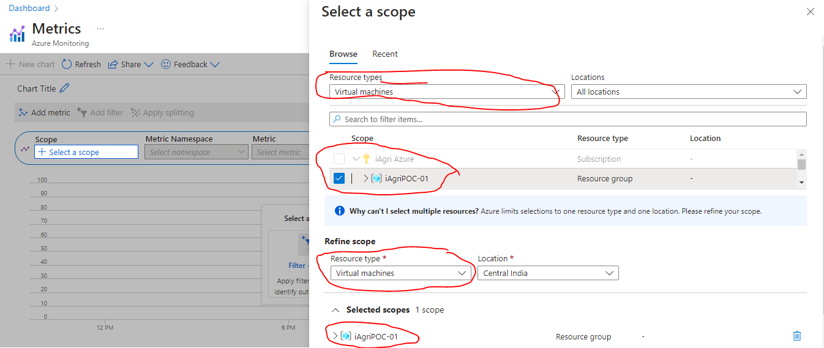

**8. Here we select VM CPU Percentage I have selected, here whatever we want based on our requirement we can select here , then save it, it will add into Dash board.**

**9. Final Dash Board will look below (here we can add application gateway and many more we can add).**

